**Project: point- and intensity-based image registration**

*Jeanine van Ingen (s163666), Lisan van Haren (s160518), Stephan van de Heisteeg (s160749), Miriam Boot (s155825)*

*[The code used for this project is provided via GitHub:* [*https://github.com/JeaninevanIngen/Mini_project_mia*](https://github.com/JeaninevanIngen/Mini_project_mia)*]*

Introduction

Image registration is the determination of a geometrical transformation that aligns one view of an object with another view of the same or another object. In medical imaging, image registration can be useful in the comparison of both inter- and intra-modal images, such as computed tomography (CT), single-photon emission computed tomography (SPECT), positron emission tomography (PET) and magnetic resonance (MR) imaging.

Image registration has many applications in daily practice. For example monitoring changes within a single subject, image-guided treatment or motion correction. Proper image registration is of major importance. It will become even more urgent with the growing number of different types of data acquisition devices and their increasing availability.1

The classification of image registration depends on many features, e.g. the type of geometrical transformation (e.g. rigid, affine), modalities (e.g. multi-modal) and subjects (inter- and intra-patient).

Two possible ways of image registration are point-based and intensity-based methods. Point-based registration uses well discernible features in both the fixed and the moving image to compute the transformed image, whereas intensity-based image registration works by iterative optimization of an intensity-based similarity measure, the normalized cross-correlation and mutual information.

The current project aims 1) to analyze point-based affine image registration in order to find the best alignment of MR brain scans with the lowest registration error and 2) to analyze and compare the alignment of images after intensity-based similarity metrics of MR brain scans using different similarity measures. Python (Spyder and Jupyter notebook) is used for image registration.

Methods

*Dataset*

The image dataset consists of 27 transverse slices of T1 and T2-FLAIR weighted MR brain scans of three different slices of three different patients in total. Every T1 slice has two versions: original and transformed with some random transformation, obtaining 3 (patients) x 3 (slices) x 3 (images per slice, t1, t1_d, t2) = 27 images in total. The image filenames have the following format: {Patient ID}_{Slice ID}_{Sequence}.tif.

Python (Spyder and Jupyter notebook) is used for image registration and git is used for the exchange of data between different group members that performed the point- and intensity-based registration.

*Point-based registration*

For point-based affine image registration, the T1 image slices with and without transformation were compared with each other, e.g. 3_2_t1.tif and 3_2_t1_d.tif. This intra-modal registration is obtained by changing the paths of the images in the point_based_registration file. Afterward, the same procedures are repeated for the inter-modal registration, pairs of the corresponding T1 and T2 slices, e.g. 3_2_t1.tif and 3_2_t2.tif.

A couple of functions are used to compute the point-based registration. My_cpselect is used to mark three locations of well perceptible features in the fixed and moving images. After point selection, the function ls_affine is used to compute the 2D affine homogeneous transformation matrix which normally can be seen as a composition of rotation, translation, scaling, reﬂection, and shearing. The affine transformation matrix in the current project, however, does not make use of reflections because reflections of corresponding intra-and inter-modal images will be a very unlikely event.

The transformation matrix will be used for inverse mapping with the function image_transform in order to transform the locations of the output image back to the original image by applying the inverse of the geometric transformations. Eventually, the aligned images are displayed as a visual aid.

The registration error of the point-based affine image registration is estimated with the function point_based_error using equation 1 (the formula of the minimization of the squared error). The convex function w and its solution can be found using equation 2.

$E^{2}={\left|\left|Aw-b\right|\right|}_{2}^{2}$ (eq. 1)

$w=(A^{T}A)^{-1}A^{T}b$ (eq. 2)

The calculated error is analyzed in intra-modal images (T1 and T1_d) and in inter-model images (T1 and T2) within patients in order to evaluate the correctness of the point-based registration method.

A right amount of corresponding point pairs in the images must be used for better reliability of the registration error. More points give a better estimation, but not too many points because then the estimation would be worse. When picking a point a user error is made, by picking more points the user error will be normalized. Another example of a better estimation is by comparing a shearing image with a fixed image the points on one side of the image can be aligned perfectly but the points on the other side of the image can be slightly misaligned.

In the model that is used within this project, an amount of three corresponding point pairs is chosen. An if statement in the my_cpselect function ensures that more than two points are selected for the calculation of the error. Afterward, three other points are picked and a test error is calculated with the same affine transformation matrix by picking the first three points.

Overall, with the functions point_based_error and point_based_registration_demo, the training error, the test error, and the transformed image are calculated.

*Intensity-based registration*

A series of different experiments are performed for analyzing and comparing the alignment of images after intensity-based similarity metrics.

1. Rigid intensity-based registration of two T1 slices is compared using normalized cross-correlation as a similarity measure.
2. Affine intensity-based registration of two T1 slices is compared:
   1. Using normalized cross-correlation as a similarity measure.
   2. Using mutual information as a similarity measure.
3. Affine intensity-based registration of a T1 and a T2 slice is compared:
4. Using normalized cross-correlation as a similarity measure.
5. Using mutual information as a similarity measure.

First, the transformation between the two images is calculated based on the image intensities starting with an identity transformation (an array with the diagonal being ones and the rest being zeros).

1. For the rigid transformations with normalized cross-correlation as a similarity measure, the function rigid_corr is used. Rigid transformations, consisting of only rotation and translation, in 2D have 3 degrees of freedom, one for the rotation angle, and two for the 2D translation vector. The function rigid_corr first computes the transformation matrix, followed by inverse mapping with the function image_transform and the calculation of the correlation.

Affine transformations have almost no restrictions on the transformation parameters. Instead of rigid transformation that only allows for rotation and translation, it has 6 degrees of freedom that allow for rotation, translation, scaling, reflection, and shearing. With it, parallel lines remain parallel after transformation. In 2D the homogeneous transformation matrix is 3x3 with the lower row being [0 0 1]. The values in the upper two rows can be any number.

1. For the affine transformation with normalized cross-correlation as a similarity measure, the function affine_corr is used. Apart from the transformation matrix, which has extra functionalities in this case, the function image_transform is comparable to the function rigid_corr.
2. For the affine transformation with mutual information as a similarity measure, the function affine_mi is used. Affine_mi uses the function joint_histogram of the images to calculate the mutual information, which is, in essence, a measure of the “compactness” of the joint histogram. Mutual information is computed using the natural logarithm.

The function ngradient is used to numerically compute the gradient of the intensity values of the images and consequently to perform optimization with the gradient ascent/descent method. The gradient ascent/descent method updates the initially chosen parameters in the images in the direction of the gradient.

The number of iterations (num_iter) is changed per set of images. The learning rate (mu) determines how fast the function ngradient moves towards the optimum of the function. Varying values of mu are used to avoid missing the maximum or minimum on the one hand and the need for too many iterations on the other hand. For the comparison of the two T1 images using mutual information, mu was guessed by first choosing a high mu with a low number of iterations and making an estimated guess of how many iterations it would take to get to the optimum with a certain learning rate. The images and learning curves are displayed for analysis and verification of the correctness of the learning parameter mu and saved afterward.

The image paths, learning rate and type of by similarity measure were manually changed depending on the image and experiment type. All other steps were adjusted automatically using if loops or kept the same.

Results

*Point-based registration*

The errors that were found for the registration per image pair after performing point-based similarity metrics are shown in table 1. Figure 1 demonstrates an example of the image transformation that was obtained after the registration, further image transformations are in appendix 1.

***Table 1. The average registration errors after point-based affine image registration of two corresponding T1 image slices (the original T1 image, and the same image with a random transformation) and of the corresponding T1 and T2 slices of the MR brain scans.***

|  |  |  |
| --- | --- | --- |
| Image slices | Average Etrain | Average Etest |
| T1 and T1 transformed | [[1,00E-15],[8,43E-16]] | [[3,52E-15],[2,42E-15]] |
| T1 and T2 | [[2,86E-15],[2,82E-15]] | [[2,72E-14],[2,41E-14]] |

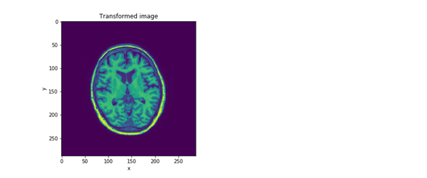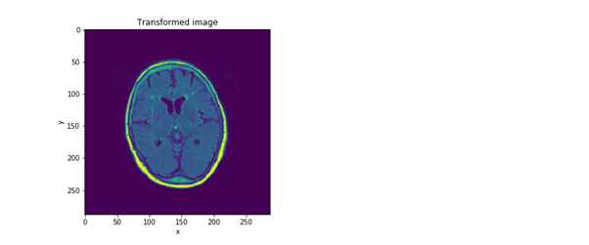

***Figure 1. Example of the transformed image of two MR brain scans after point-based similarity metrics of two corresponding T1 image slices (the original T1 image, and the same image with a random transformation) (left) and the corresponding T1 and T2 slices (right).***

*Intensity-based registration*

All images are compared with each other in a similar manner. For clarity, only one image is shown per series of experiments of the optimized images and their corresponding learning rate curves after performing intensity-based similarity metrics (figure 3). Additional figures can be found in appendix 2. For the comparison of the two T1 images using mutual information, a for-loop was used for the final five image pairs with a high number of iterations and a low learning rate since the running of the function took too long and this could be run overnight.

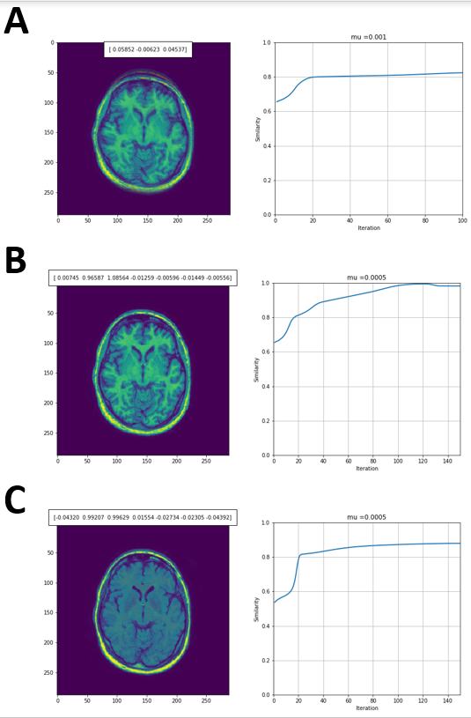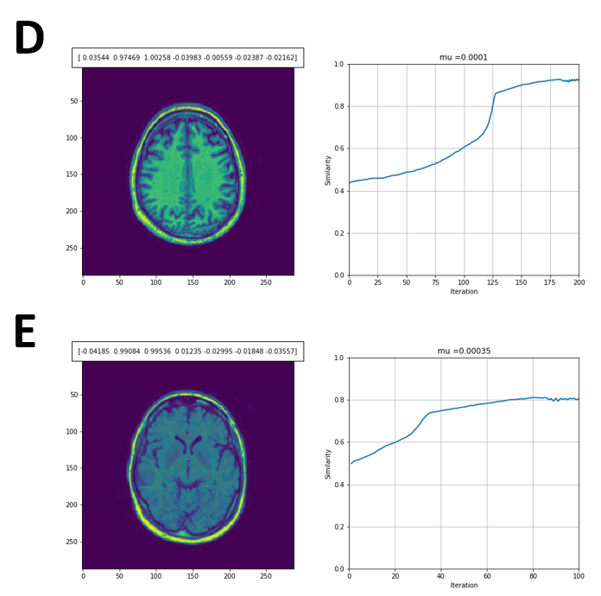***Figure 3. An example of optimized MR brain images and their corresponding learning rate curves (right) after performing intensity-based registration using several types of similarity measures. Registrations are performed on either two T1 slices (the original T1 image, and the T1 image with a random transformation) or corresponding T1 and T2 slices.*** *(A) Rigid intensity-based registration of two T1 slices using normalized cross-correlation, (B) affine intensity-based registrations using normalized cross-correlation on two T1 slices and (C) on a T1 and T2 slice, (D) affine intensity-based registrations using mutual information on two T1 slices and (E) on a T1 and T2 slice.*

Discussion

The aim of the current project is to analyze and compare individual point- and intensity-based image registrations of MR brain scans with Python using different similarity measures. The present project shows an overall high alignment between T1 images and their same image with a random transformation, and between T1 and T2 images using image registration.

*Point-based registration*

As mentioned in the method the amount of point selection has an effect on the estimation of the error. In this project, three different points are selected for the calculation of the error. By using a few corresponding point pairs, the calculated registration error will be the maximum of multiple selected points and, therefore, less prone to occasional errors of the user in point selection, e.g. the error of the error selection. On the other hand, too many selected points for the calculation of the error could overestimate the error because the formula returns the largest error found.   
The overall registration error after point-based affine image registration is found to be very low, indicating that the compared images are decently aligned after registration. The average error has a small order of magnitude of e-15. The obtained errors between image slices make a proper comparison between T1 image slices (the original T1 image, and the same image with a random transformation) and corresponding T1 and T2 image slices impossible. Therefore, no conclusions can be drawn yet based on these comparisons.

*Intensity-based registration*

The alignment of the images using intensity-based similarity metrics is found to be reasonably high with similarity values between 0.7 and 1.0 on a scale of 0.0 to 1.0.

On average, aligned T1 image slices tend to show a higher similarity after intensity-based image registration than the corresponding T1 and T2 images. Presumably, the difference is caused by the fact that the two T1 images are exactly the same image but one has an affine transformation applied. Furthermore, this finding suggests that the current code is mainly applicable for intra-modal image registrations and that predominantly inter-modal image registrations need to be optimized.

The overall similarity of corresponding T1 images is higher using affine correlation than using rigid correlation. When affine correlation was used nearly all image pairs could be aligned with near 1 similarity. A possible explanation for the difference in findings between both transformations might be that rigid transformations consist of only rotation and translation whereas affine transformations use the six degrees of freedom that have been used to misalign the image, resulting in a much more accurate transformation matrix. Therefore a higher similarity can be obtained between the images by using affine correlation.

Similar similarities are found in the alignment of T1 and T2 images after affine normalized cross-correlation and mutual information. This agreement in similarity values is not expected as mutual information makes fewer assumptions about the relationship between image intensities in the moving and fixed images than normalized cross-correlation, which assumes a linear relationship. The similarity in outcomes may be caused by the artificialness of the used image slices as will be discussed later.

*Strengths and limitations*

A major strength of the current project is its diversity in experiments with various similarity measures using both inter- and intra-modal MR brain images. This completeness facilitates the reader in getting an overview of the current registration techniques and their precision. Furthermore, because of the simplicity of the used python code, the less experienced users will be able to perform and understand the image-based registrations themselves.

There are several important limitations of the current project that should be considered. One of the main weaknesses of this project is the function of mutual information which runs very slow due to the programming code used. This made it impossible to perfectly align the two T1 images since the number of iterations needed for this made the code run way too long. It took more than an hour to run the 200 iterations alignments and first the right learning rate had to be determined what took multiple test runs. Therefore, obtaining registrations using mutual information was very time consuming and not user-friendly. Future studies should incorporate a different type of code that is able to run the function more quickly.

Furthermore, intensity-based registration, in general, should need little user interaction. Multiple test runs were needed to determine the right learning rate, the intensity-based registration took more interaction from the user than the determination of a few points in point-based registration. On the other hand, the found errors with point-based registration metrics were unreliably small suggesting that similarity might be a better measure for alignment of images in the present setting. Besides, the boundary values for the errors or its units are not known while it is known that similarity is any value between 0 and 1. One of the contributions to the small errors is the square in equation 1, which decreases the already small errors.

Another important limitation is the use of the small sample size with only 27 MR scans of three patients, which made the use of statistics for the evaluation impossible. Besides, the current project uses T1 image slices of original images and the same images with artificially retrieved random transformations. In daily practice, images could suffer from for example movements of the patient or organs, or changes caused by interventions between the acquisition of the images. It is unknown to what extent the transformations of the current project correspond with situations in daily practice, and if images in practice will show the same level of alignment using these similarity metrics. Further research should incorporate a larger sample size with MR scans from daily practice to statistically confirm the found results.

Appendix

*Appendix 1*

|  |  |  |  |
| --- | --- | --- | --- |
| Images |  | Errors | Transformed image |
| 1_1_t1.tif and 1_1_t1_d.tif | Etrain:    Etest: | [[1.13074944e-23]  [9.02487168e-24]]  [[2.38565270e-22]  [1.24031855e-22]] |  |
| 1_2_t1.tif and 1_2_t1_d.tif | Etrain:    Etest: | [[2.42325953e-23]  [1.23608572e-23]]  [[3.41797653e-24]  [1.47640430e-23]] |  |
| 1_3_t1.tif and 1_3_t1_d.tif | Etrain:    Etest: | [[4.28938384e-24]  [1.28681515e-24]]  [[2.47203007e-23]  [8.97377874e-24]] |  |
| 2_1_t1.tif and 2_1_t1_d.tif | Etrain:    Etest: | [[3.33699523e-24]  [1.41000367e-24]]  [[5.64991016e-24]  [6.64167871e-24]] |  |
| 2_2_t1.tif and 2_2_t1_d.tif | Etrain:    Etest: | [[6.95045780e-24]  [6.68065475e-24]]  [[4.09397858e-23]  [5.75771021e-23]] |  |
| 2_3_t1.tif and 2_3_t1_d.tif | Etrain:    Etest: | [[9.20016288e-24]  [1.32066170e-23]]  [[8.60300149e-26]  [1.88215901e-25]] |  |
| 3_1_t1.tif and 3_1_t1_d.tif | Etrain:    Etest: | [[1.44952497e-23]  [1.62885514e-23]]  [[1.78522378e-25]  [6.22001047e-25]] |  |
| 3_2_t1.tif and 3_2_t1_d.tif | Etrain:    Etest: | [[1.13099177e-23]  [9.50954782e-24]]  [[2.56070561e-24]  [3.29741334e-24]] |  |
| 3_3_t1.tif and 3_3_t1_d.tif | Etrain:    Etest: | [[4.98671164e-24]  [6.06006734e-24]]  [[1.05598814e-24]  [1.55520456e-24]] |  |
| 1_1_t1.tif and 1_1_t2.tif | Etrain:    Etest: | [[1.62225143e-24]  [1.20805528e-24]]  [[4.12156473e-24]  [6.26201573e-24]] |  |
| 1_2_t1.tif and 1_2_t2.tif | Etrain:    Etest: | [[1.77025941e-22]  [1.80136350e-22]]  [[2.37997492e-21]  [2.11945726e-21]] |  |
| 1_3_t1.tif and 1_3_t2.tif | Etrain:    Etest: | [[6.64188066e-24]  [5.11434302e-24]]  [[1.83066217e-24]  [4.71105208e-24]] |  |
| 2_1_t1.tif and 2_1_t2.tif | Etrain:    Etest: | [[4.49698679e-23]  [3.75060573e-23]]  [[2.82626774e-23]  [1.37076510e-23]] |  |
| 2_2_t1.tif and 2_2_t2.tif | Etrain:    Etest: | [[1.73837176e-24]  [1.68828855e-24]]  [[9.19269079e-25]  [7.11666132e-25]] |  |
| 2_3_t1.tif and 2_3_t2.tif | Etrain:    Etest: | [[1.31266455e-23]  [1.22614986e-23]]  [[3.17058975e-26]  [1.39344390e-26]] |  |
| 3_1_t1.tif and 3_1_t2.tif | Etrain:    Etest: | [[8.30815684e-25]  [1.05578619e-24]]  [[6.29957813e-24]  [4.07228932e-24]] |  |
| 3_2_t1.tif and 3_2_t2.tif | Etrain:    Etest: | [[1.09565080e-23]  [1.50483864e-23]]  [[2.58269779e-23]  [2.25099755e-23]] |  |
| 3_3_t1.tif and 3_3_t2.tif | Etrain:    Etest: | [[1.62568455e-25]  [1.52672984e-25]]  [[1.1610013e-24]  [1.2060358e-24]] |  |

*Appendix 2*

All individual optimized MR brain images (left) and their corresponding learning rate curves (right) after performing intensity-based registration. The image filenames have the following format: {Patient ID}_{Slice ID}_{Sequence}.tif. The values for the learning rates mu are adjusted per image and are displayed as the title.

1. *Rigid intensity-based registration using normalized cross-correlation on two T1 slices.*

|  |  |
| --- | --- |
| Images | Transformed image |
| 1_1_t1.tif and 1_1_t1_d.tif |  |
| 1_2_t1.tif and 1_2_t1_d.tif |  |
| 1_3_t1.tif and 1_3_t1_d.tif |  |
| 2_1_t1.tif and 2_1_t1_d.tif |  |
| 2_2_t1.tif and 2_2_t1_d.tif |  |
| 2_3_t1.tif and 2_3_t1_d.tif |  |
| 3_1_t1.tif and 3_1_t1_d.tif |  |
| 3_2_t1.tif and 3_2_t1_d.tif |  |
| 3_3_t1.tif and 3_3_t1_d.tif |  |

1. *Affine intensity-based registrations using normalized cross-correlation on two T1 slices.*

|  |  |
| --- | --- |
| Images | Transformed image |
| 1_1_t1.tif and 1_1_t1_d.tif |  |
| 1_2_t1.tif and 1_2_t1_d.tif |  |
| 1_3_t1.tif and 1_3_t1_d.tif |  |
| 2_1_t1.tif and 2_1_t1_d.tif |  |
| 2_2_t1.tif and 2_2_t1_d.tif |  |
| 2_3_t1.tif and 2_3_t1_d.tif |  |
| 3_1_t1.tif and 3_1_t1_d.tif |  |
| 3_2_t1.tif and 3_2_t1_d.tif |  |
| 3_3_t1.tif and 3_3_t1_d.tif |  |

1. *Affine intensity-based registrations using normalized cross-correlation on a T1 and a T2 slice.*

|  |  |
| --- | --- |
| Images | Transformed image |
| 1_1_t1.tif and 1_1_t2.tif |  |
| 1_2_t1.tif and 1_2_t2.tif |  |
| 1_3_t1.tif and 1_3_t2.tif |  |
| 2_1_t1.tif and 2_1_t2.tif |  |
| 2_2_t1.tif and 2_2_t2.tif |  |
| 2_3_t1.tif and 2_3_t2.tif |  |
| 3_1_t1.tif and 3_1_t2.tif |  |
| 3_2_t1.tif and 3_2_t2.tif |  |
| 3_3_t1.tif and 3_3_t2.tif |  |

1. *Affine intensity-based registrations using mutual information on two T1 slices.*

|  |  |
| --- | --- |
| Images | Transformed image |
| 1_1_t1.tif and 1_1_t1_d.tif |  |
| 1_2_t1.tif and 1_2_t1_d.tif |  |
| 1_3_t1.tif and 1_3_t1_d.tif |  |
| 2_1_t1.tif and 2_1_t1_d.tif |  |
| 2_2_t1.tif and 2_2_t1_d.tif |  |
| 2_3_t1.tif and 2_3_t1_d.tif |  |
| 3_1_t1.tif and 3_1_t1_d.tif |  |
| 3_2_t1.tif and 3_2_t1_d.tif |  |
| 3_3_t1.tif and 3_3_t1_d.tif |  |

1. *Affine intensity-based registrations using mutual information on a T1 and a T2 slice.*

|  |  |
| --- | --- |
| Images | Transformed image |
| 1_1_t1.tif and 1_1_t2.tif |  |
| 1_2_t1.tif and 1_2_t2.tif |  |
| 1_3_t1.tif and 1_3_t2.tif |  |
| 2_1_t1.tif and 2_1_t2.tif |  |
| 2_2_t1.tif and 2_2_t2.tif |  |
| 2_3_t1.tif and 2_3_t2.tif |  |
| 3_1_t1.tif and 3_1_t2.tif |  |
| 3_2_t1.tif and 3_2_t2.tif |  |
| 3_3_t1.tif and 3_3_t2.tif |  |

Sources

[1] Zbilut, Joseph & Webber, Charles. (2006). Wiley Encyclopedia of Biomedical Engineering. 10.1002/9780471740360.ebs1355.